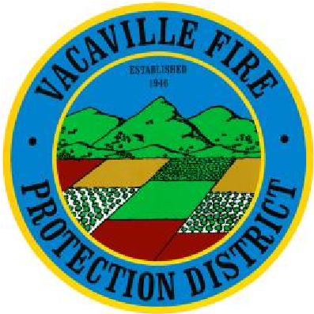
VACAVILLE FIRE PROTECTION DISTRICT
DAY STATION COVERAGE
REIMBURSEMENT PROGRAM

For reimbursement to be considered you must be within compliance with drill attendance. Please refer to the drill attendance policy.

SECTION 1. INTRODUCTION

- The Vacaville Fire Protection District (VFPD) has a robust volunteer program which includes some volunteers providing station coverage for the district, from 7:00 AM – 5:00 PM. The primary purpose of this policy is to clarify VFPD’s reimbursement, solely related to the station coverage that is chosen by the volunteer.

- Duties will include responding to all emergency alarms, supporting the station with whatever operation is needed, including cleaning and maintenance, and 1 hour of required training.

- The reimbursement program is only available to volunteers who meet the qualifications, not paid staff.

- All other program rules, regulations, policies and procedures will be directed by the Fire Chief.

- All Vacaville Fire Protection District Policies and Procedures are applicable.

- If an individual cannot cover the date they chose, thus requiring another volunteer to cover, the individual that covered and incurred the expense will be reimbursed.

- The reimbursement is on an as needed basis and based on business need from station 64. As a result, the amount of time listed to cover a shift may be diminished based on staffing.

- This program is subject to change and can be cancelled at any time, without notice.

- Any funds that you did not realize must be returned to the district.

- In order to provide equity to everyone, you cannot work two (2) tangent shifts. (Example: cannot work a night shift and day shift back-to-back).

SECTION 2. REIMBURSEMENTS

Volunteer firefighters are bona fide volunteers volunteering their services freely for civic, charitable, or humanitarian reasons. As such, volunteer firefighters shall not receive any compensation or benefits for their services to VFPD. However, so as not to deter volunteers due to expenses involved with being a volunteer, VFPD shall reimburse the volunteer during station coverage at a rate of one hundred and twenty-five dollars ($125) per station shift. The $125 reimbursement is intended for uniform cleaning and maintenance (including boot polish, supplies, and repair), as well as meals while away from home, fuel, and cell phone expenses. These per-shift expenses are estimated as set forth in the attached Exhibit A. Because this is intended as reimbursement for expenses and not as compensation. Since it is considered an unaccountable plan according to the IRS regulations, the volunteer’s reimbursement will be reduced by whatever taxes are required.

EXHIBIT A

Estimate of Expenses per Station Coverage

Uniform Allowance (Up to) $62
May include:
Cleaning of structure gear
Cleaning of grass gear
Cleaning of Class B
2nd Pair of Class B
Clothing repair
Purchase of replacements
Wear and tear
Boot Polish Supplies / Repair $6
Meal Expense - Lunch $35
Fuel Expense/Wear and Tear of Use $12
Cell Phone (paid staff have spare) $0
Personal hygiene incidentals $10
TOTAL $125

- Since uniforms have specialized fire-retardant material to meet safety standards standard laundromat services may damage the uniform/gear. Additional care is needed, which results in a more costly process to ensure it does not reduce the level of fire protection on the clothing, which would otherwise impact safety.
- Below are the State approved levels for reimbursement of meals provided by Cal OES effective March 1, 2024. Fore the day shift only lunch is approved.
  - 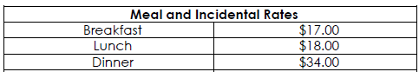
- Fuel expense is to cover using their personal vehicle to travel to and from the station in addition to wear and tear on the personally owned vehicle.
- Cell costs are not incurred during the day shift, since day staff have department cell phones available.

